Pourerere Freedom Camping Ballot Policy

Adopted: [Adoption Date]

Review:



*Together we thrive! E ora ngātahi ana!*

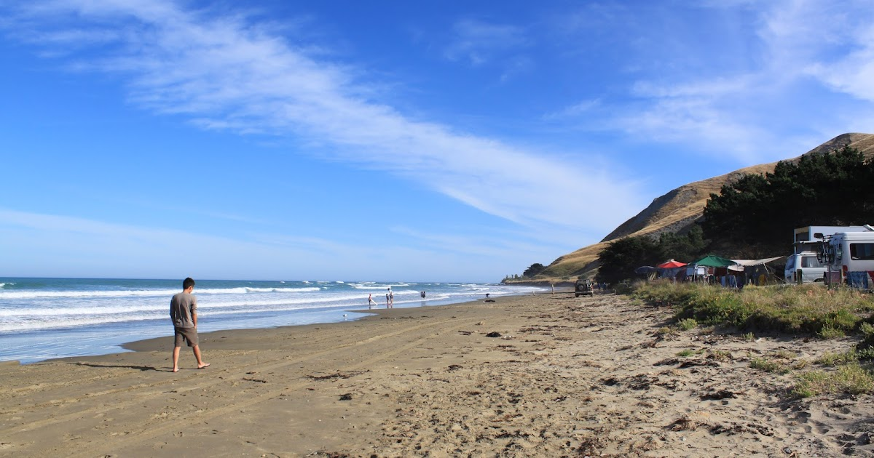

### POURERERE FREEDOM CAMPING

**Introduction**

Central Hawke’s Bay District Council adopted its first ever [Freedom Camping Bylaw](https://www.chbdc.govt.nz/assets/Document-Library/Consultation/Freedom-Camping-Bylaw/20240627-Central-Hawkes-Bay-District-Council-Freedom-Camping-Bylaw.pdf) (the Bylaw) on 27 June 2024, consistent with the Freedom Camping Act 2011. The Bylaw outlines how Council will manage freedom camping at different sites throughout the district.

There are two freedom camping sites identified in the Bylaw at Pourerere (see appendix 3):

* Tommy Ireland point, which is identified as a restricted area for self-contained motor vehicles only (maximum of 3 nights stay)
* Pourerere Beach Road, located on Road Reserve, which is identified as a permitted freedom camping area, for both self-contained and non-self-contained vehicles. There are seasonal rules to manage camping at this site during the peak summer camping season (14 December – 29 February). During this time a 14-night permit is required, allocation of which is determined through a ballot system.

When Council adopted the Bylaw on 27 June 2024, it tasked Council Officers to work with the Pourerere Camping Committee and the broader Pourerere Community to develop and formalise an operational campsite allocation and management policy for the Pourerere Beach Road Reserve camping area, with clear roles for Council and the Committee to ensure a fair and transparent process for the allocation of sites through the peak summer season.

This is to recognise the long-standing relationship that exists between the Pourerere Camping Committee and the Central Hawke’s Bay District Council, which allows for the unique management of freedom camping at Pourerere Beach Road Reserve.

It also recognises that during the public consultation process on the draft Bylaw, many submitters identified a perceived lack of fairness in the way permits for this area were allocated historically. This policy aims to address these issues.

The Pourerere Beach Road Reserve consists of 40 marked sites that are available for freedom camping year-round. During the peak season (14 December through to 29 February each year), these 40 sites are available through the issuance of permits that are allocated via a ballot process (described below).

Council provides limited sanitary and rubbish collection services during the peak summer season at Pourerere Beach Road Reserve and administers / manages camping at this location at a cost to the general ratepayer. While Council cannot charge for camping permits under the Freedom Camping Act 2011, voluntary contributions/Koha from campers are strongly encouraged to ensure the sustainability of the provision of these services and to ensure camping opportunities at this location can endure over time. Voluntary contributions can be made to the following bank account 01 0777 0038665 00 ref Freedom Camping

**Freedom camping campsite allocation and management policy**

This operational policy outlines how campsites at Pourerere Beach Road Reserve will be allocated and managed through the peak summer season. This operational Policy outlines the intent of Council and is consistent with Council’s [Camping Strategy](https://www.chbdc.govt.nz/assets/Document-Library/Thriving-Places-and-Spaces/FINAL-Camping-Strategy.pdf), the [Freedom Camping Bylaw](https://www.chbdc.govt.nz/assets/Document-Library/Consultation/Freedom-Camping-Bylaw/20240627-Central-Hawkes-Bay-District-Council-Freedom-Camping-Bylaw.pdf), the [Freedom Camping Act 2011](https://www.legislation.govt.nz/act/public/2011/0061/latest/DLM3742815.html) and the [Self-contained Motor Vehicles Legislation Act 2023](https://www.legislation.govt.nz/act/public/2023/0024/latest/LMS737445.html).

The Bylaw is intended to minimise any negative effects from freedom camping to the environment and to maintain and nurture the relationship with the kaitiaki, community and costal visitors.

This policy will remain a ‘live-document’ and officers will update the policy as required to ensure it remains fit-for-purpose over time.

**Objectives**

The objectives of this policy are to:

1. Ensure fair and equitable allocation of sites during the peak season.
2. Maintain effective working relationships with the Pourerere Camping Committee and broader Pourerere community to support the management of the peak summer camping season.
3. To provide for the Camping Committee to take a kaitiaki role in the area, during peak times, supported by local hapu.
4. Prioritise camping opportunities for Central Hawke’s Bay locals (in accordance with the Camping Strategy).

**Ballot System**

**Campsite allocation**

As per Schedule 3 of the Bylaw, the peak season for Pourerere Beach Road Reserve is from 14 December through to 29 February each year. This is the timeframe for which a permit is required to camp (maximum of 14 nights), to be allocated through a balloting system (outlined below).

There are fourty (40) campsites at the Pourerere Beach Road Reserve. As per the table below, not all sites are suitable for caravans, campervans, or motorhomes.

Council officers have worked with the Pourerere Camping Committee to develop and formalise a policy to ensure a fair and transparent process is established to allocate campsites for the peak summer season. This is because the Pourerere Camping Committee plays an integral role in supporting Council to manage the peak freedom camping season.

In working through the details of the policy, the Pourerere Camping Committee highlighted the importance of ensuring that access to campsites was provided for the Committee as a priority in the peak season, noting that they take a role supporting the operation of the freedom camping area.

As such for the period 21 December 2024 – 12 January 2025 the Pourerere Freedom Camping Committee is allocated twenty (20) sites that the Committee can permit for at their discretion from the pool of those that have applied for permits. This means that for this period twenty (20) sites are made available to the public through the ballot process – with a priority being given to Central Hawke’s Bay residents.

For the remainder of the season (14 December 2024 – 20 December 2024 and 13 January 2025 – 28 February 2025) the Pourerere Camping Committee is allocated ten (10) sites that the Committee can permit for at their discretion (from the pool of those that have applied for permits)..The remainder thirty (30) sites are allocated through the ballot process as described below.

Summary table

|  |  |  |
| --- | --- | --- |
| **Period** | **Campsites allocated by Council** | **Campsites allocated by Committee** |
| 14 Dec – 20 Dec | 30 | 10 |
| 21 Dec – 12 Jan | 20 | 20 |
| 13 Jan – 28 Feb | 30 | 10 |

**Ballot**

The ballot for the allocation of permits is conducted as follows:

1. Applications are opened by the Council late September yearly.
2. Applications are to be submitted through the online registration form on the Council web page – no application received; no permit issued.
3. Applications are open for a period of four weeks.
4. Priority will be given to Central Hawke’s Bay residents, as described in Appendix 1. Proof of address may be requested.
5. The Pourerere Camping Committee will specify the sites required for the Committee-allocated sites. Recipients of Committee-allocated sites will be removed from the general ballot.
6. Permit applicants for the Council-allocated sites will be selected by officers through a computer-generated randomised system.
7. Successful applicants will be allocated sites, conditional on method of camping and availability of suitable camp sites.[1]
8. Officers will meet with the Pourerere Camping Committee (mid – November) to finalise the allocation of camp sites for both Council and Committee-allocated sites.
9. Successful applicants/permit holders will be notified and provided induction information contained in Appendix 2 by late November.
10. Unsuccessful applicants will be notified and be placed on a waiting list if a campsite becomes available.
11. Unsuccessful applicants will be provided the ability to backfill any sites that haven’t been allocated to maximise usage, e.g., at dates different to those initially applied for.
12. Successful applicants/permit holders who can no longer use their permits must notify the Council as soon as possible. Permits will be re-allocated to applicants on the waiting list.
13. Usage of the permits and campsites will be monitored. ‘No shows’ (i.e., without Council being notified) will result in instantaneous loss of permit, to be re-allocated by the Committee with support from officers to applicants on the waiting list. Low usage may disqualify future allocation of sites.

Officers and the Pourerere Camping Committee have agreed to review the campsite allocation process following completion of the 2024/2025 camping season.

##### **Management of freedom camping at Pourerere**

The Central Hawke’s Bay District Council [Freedom Camping Bylaw](https://www.chbdc.govt.nz/assets/Document-Library/Consultation/Freedom-Camping-Bylaw/20240627-Central-Hawkes-Bay-District-Council-Freedom-Camping-Bylaw.pdf) applies to all campsites at this location, and breaches of the Bylaw will be enforced by an authorised Officer.

Council Officers will work closely with the Pourerere Camping Committee to manage camping throughout the peak season.

**Future development opportunities**

Both the Committee, Council and Hapū have acknowledged that there are joint responsibilities in protecting and progressing the wider long-term aspirations along the coast. The Central Hawke’s Bay Reserves Management Plan 2022 began to speak to these priorities which included:

* Developing joint decision making/management approaches for reserves
* Clarifying the role of the camping committee
* Working with hapū to understand their aspirations for the reserve known as Tuingara Point long term.
* Providing visibility of Mana whenua on the coast through pou and art
* Addressing coastal erosion
* The future of the camping and future camping aspirations at Pourerere

1. Officers will use their discretion if there are insufficient suitable campsite to cater for different methods of camping.